**Live Demo Workflow**

**SQL2K8 Server from vCenter to Azure Stack as Lift-Shift Migration**

Kulkarni, Vivek K

HPE - Azure Stack Innovation Center

Contents

1. Purpose 1

2. Intended Audience 1

3. Source Environment 2

4. Target Environment 2

5. Lift Shift Migration Procedure with CommVault Solution 2

5.1 Source and Target Environment Connections 2

5.2 Source Environment – SQL2008 Workload in Source Environment 4

5.4 Backup virtual machine from Source Environment 4

5.5 Restore Virtual Machine to Target Environment 7

5.6 Post Migration Verifications in Target Environment 14

# Purpose

Purpose of this document is to list procedure to run a live demo of SQL2008-Server (with sample datavase running) from vCenter based Windows-2008-Server virtual machine to virtual machine in Azure Stack subscription.

The migration tool used is CommVault CommServe with feature set to backup & restore virtual machine between vCenter and Azure Stack.

**IMPORTANT NOTE**:

* This demonstration is for lift-shift migration of virtual machine host running SQL2008 workload
* This doc is based on live environment consisting of :
  + HPE Proliant for Azure Stack (DL380 config with Azure Stack build 1902)
  + VmWare vCenter with one Esxi host
  + SQL2008 server database running on Windows2008-R2 operating system hosted as virtual machine in Esxi host

# Intended Audience

HPE field teams in need to showcase HPE Proliant for Azure Stack solution as virtualization platform for migrating SQL2008 workloads to Azure Stack using lift-shift model for migration

# Source Environment

* VmWare vCenter with one Esxi host
* SQL2008 server database running on Windows2008-R2 operating system hosted as virtual machine in Esxi host

# Target Environment

* Platform: HPE Proliant for Azure Stack (DL380 config with Azure Stack build 1902)
* Azure Stack User subscription

# Lift Shift Migration Procedure with CommVault Solution

## Source and Target Environment Connections

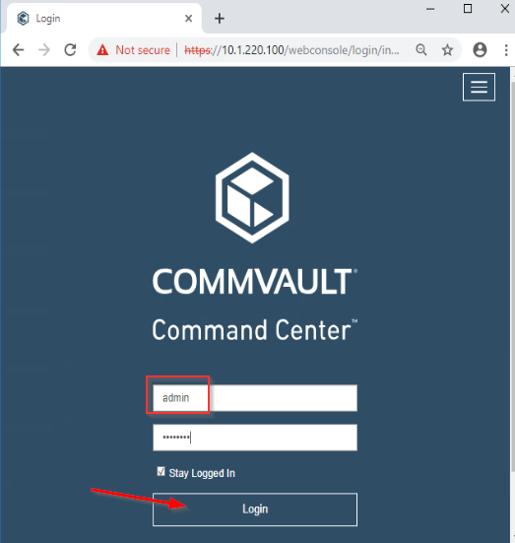

* Highlight list of virtualization environments added under hypervisors

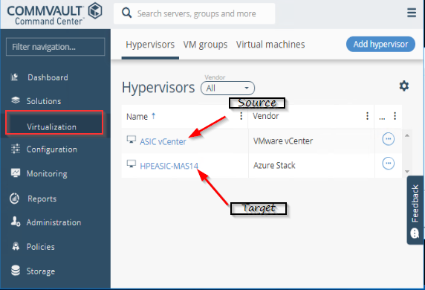

* For curious minds details provided for source/target environment are:
  + Source
    - 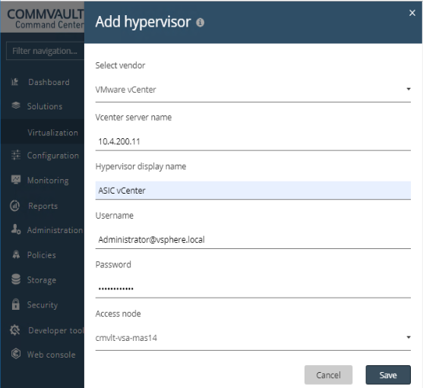
  + Target:
    - 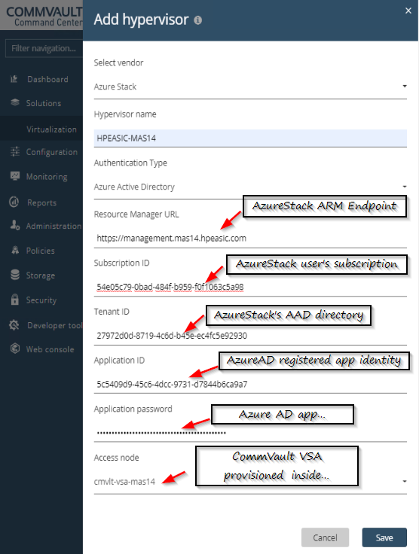

## 5.2 Source Environment – SQL2008 Workload in Source Environment

1. **<TBD>** Capture screenshots from vCenter showing source VM
2. **<TBD>** Capture screenshots of SQL db running from within SQL2K8 server RDP session. Highlight ip address used in db connection string.
3. **<TBD>** Capture screenshots of SQL query results run from SMSS on JumpBox. Highlight the connection string to source VM’s ip address

Target Environment – Azure Stack subscription

## 5.4 Backup virtual machine from Source Environment

IMPORTANT NOTE: All actions listed below are run from CommVault web console

1. View VM’s available from vCenter organized as VM groups

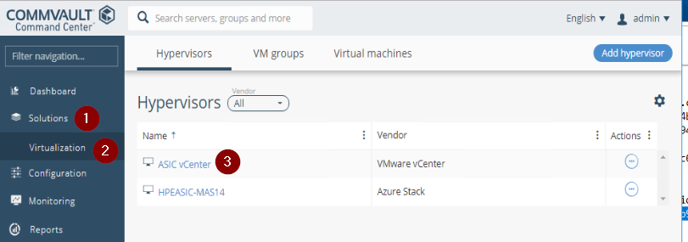

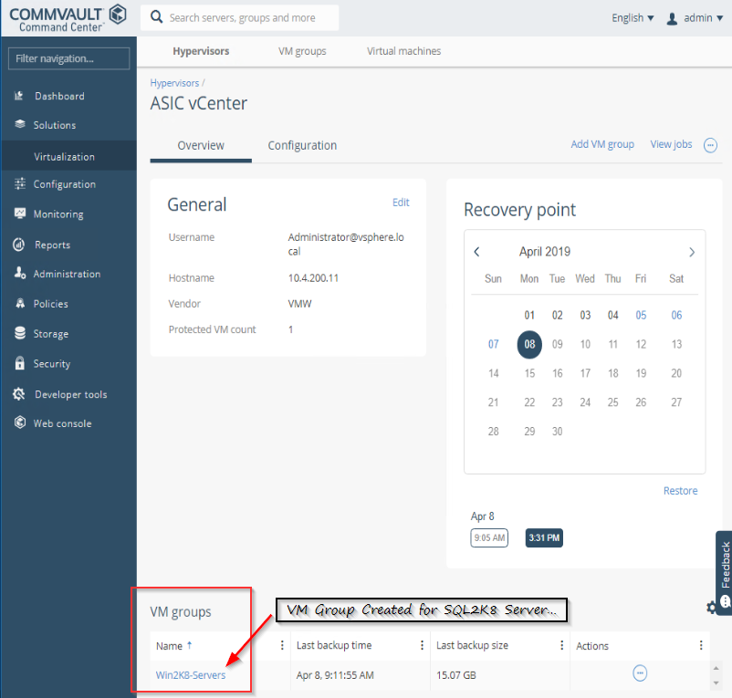

1. Run backup of selected SQL2K8-server VM

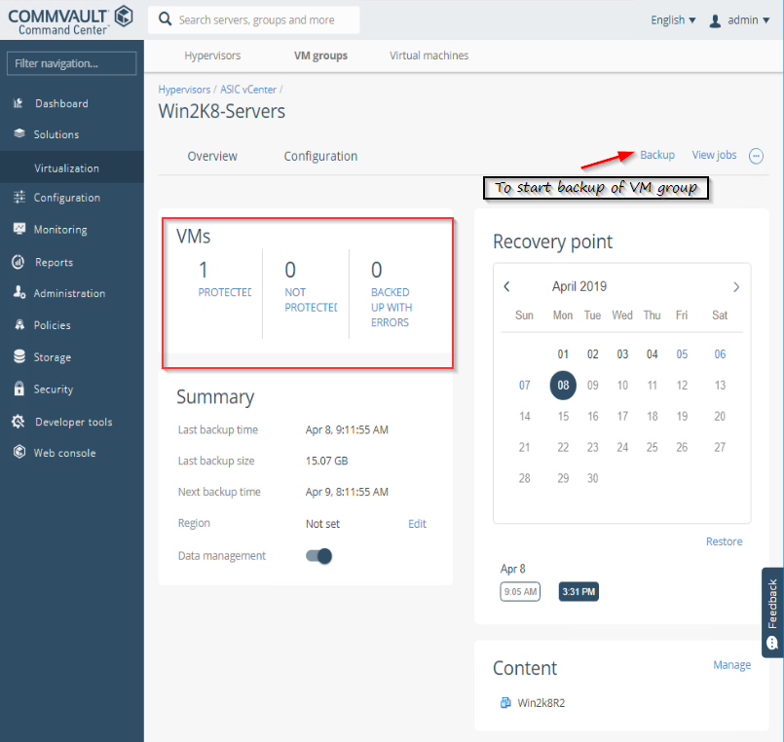

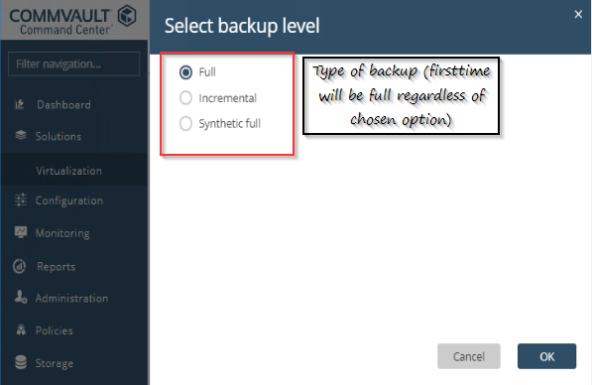

1. Note down backup copy time stamp. This will be used to restore in target environment

## 5.5 Restore Virtual Machine to Target Environment

**IMPORTANT NOTE**: CommVault’s web console doesn’t fully support restore to Azure Stack. Need to use aunch CommVault’s java app console

* RDP into CommVault server
* Launch commVault java app and log in

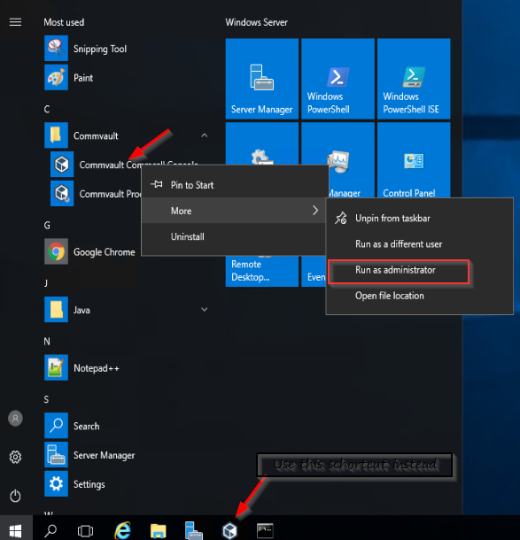

* Browse to backed up VM set and select ‘browse and restore’

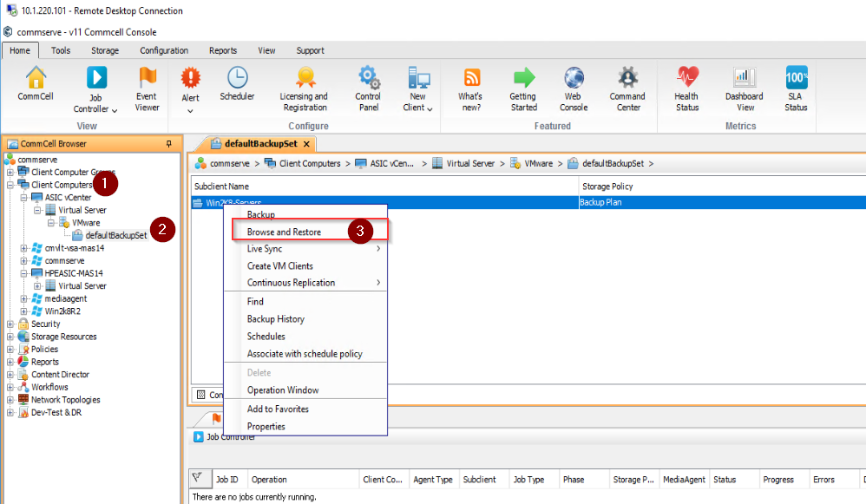

* Select Azure Stack as restore target environment for virtual machine group and click ‘View Content’. This will bring up list of virtual machines from VM group that have backed up copy available.

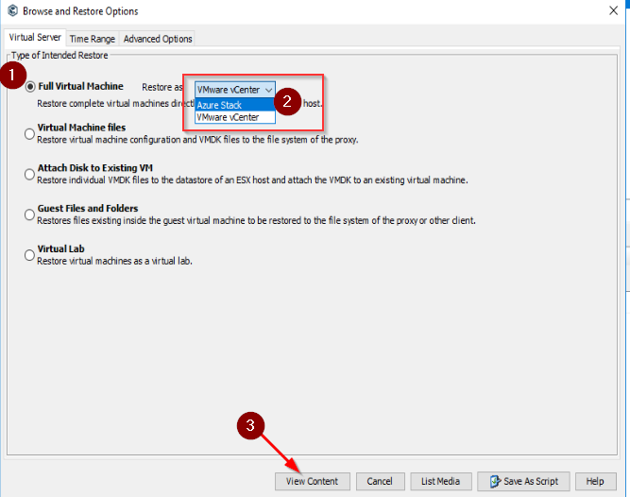

* Select the virtual machine and click ‘Recover All Selected’

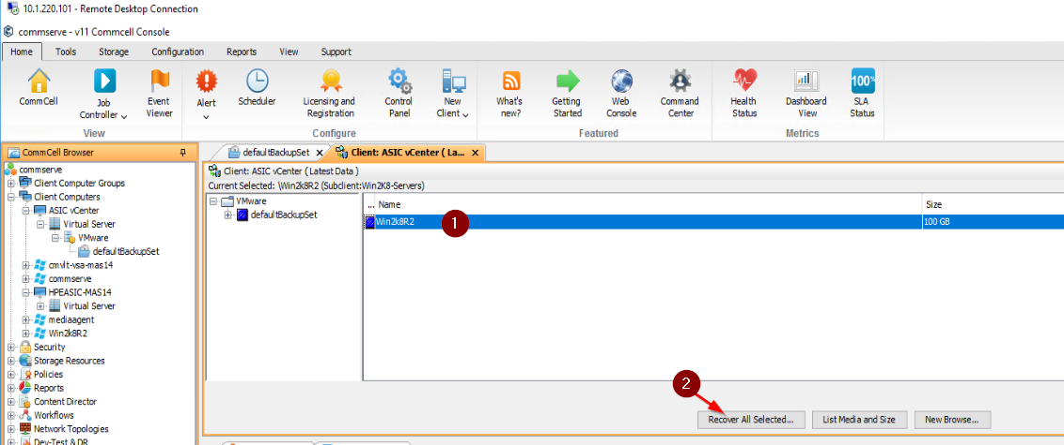

* Carefully populate details from target environment. Since the target environment is Azure Stack highlight below details in series of dialogs.
  + Azure Stack’s user subscription, VSA on Azure Stack

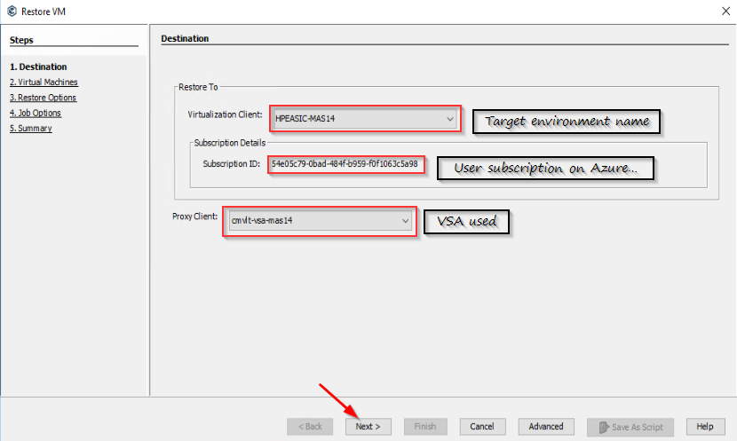

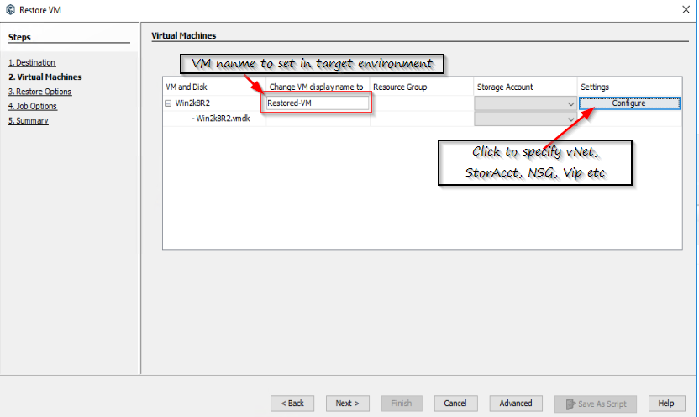

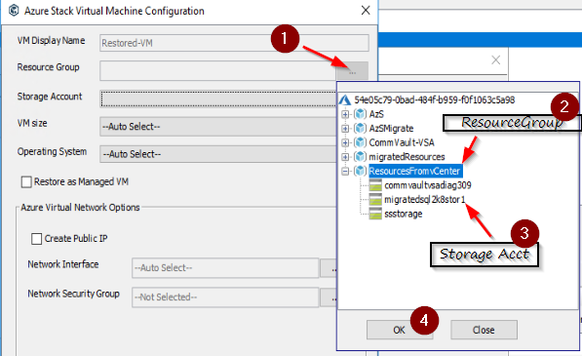

* + Select ‘Create Public IP’
  + Choose correct virtual network to place NIC for the restored VM

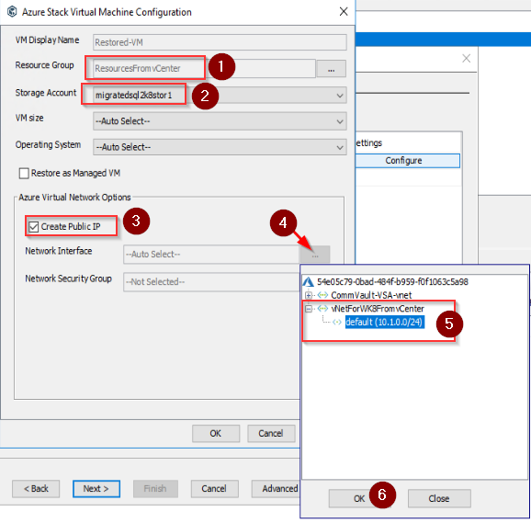

* + Select NSG to use for NIC that’ll be created for restored VM

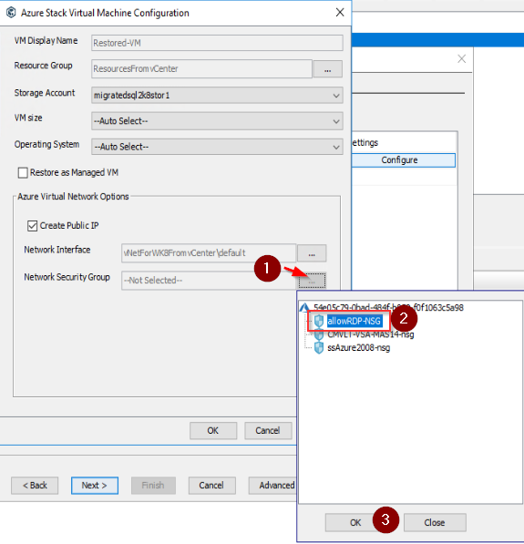

* + Fully populated target environment would look like below:

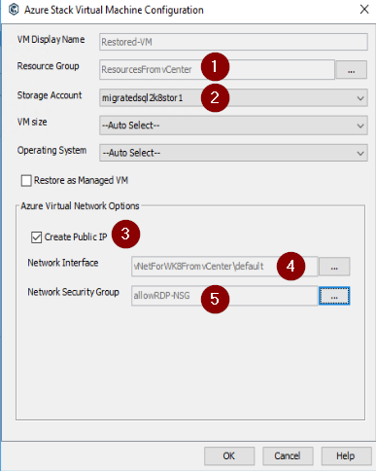

* + After populating all correct parameters from target environment click ‘next’

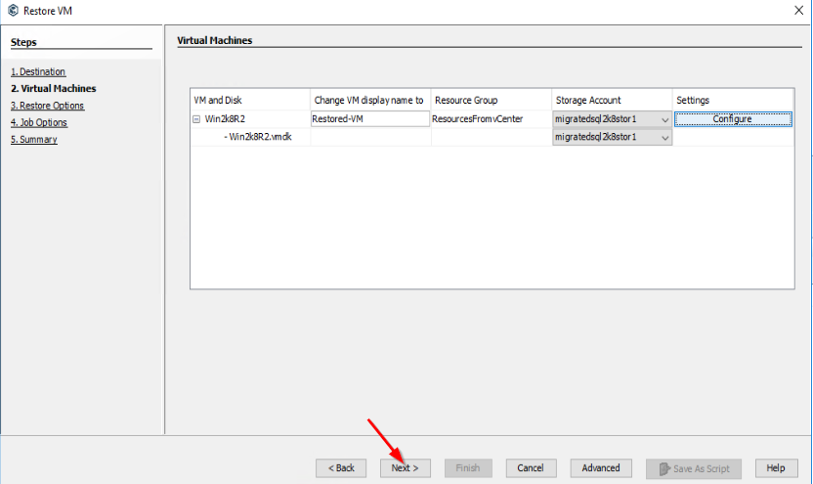

* + Choose power, overwrite VM options for restore operation and click next

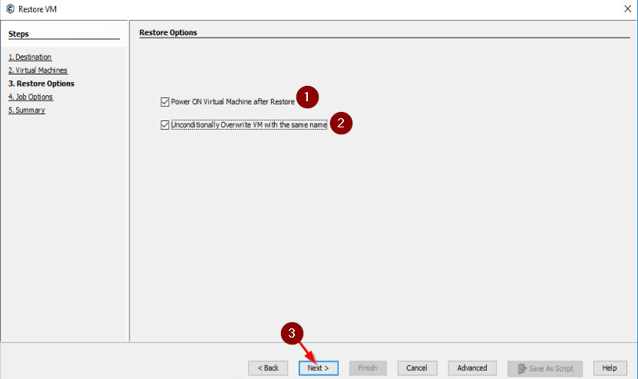

If prompted with option Y/N to overwrite, choose Yes

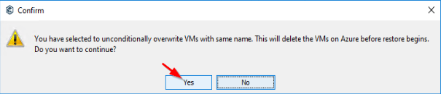

* + Choose option to run immediately

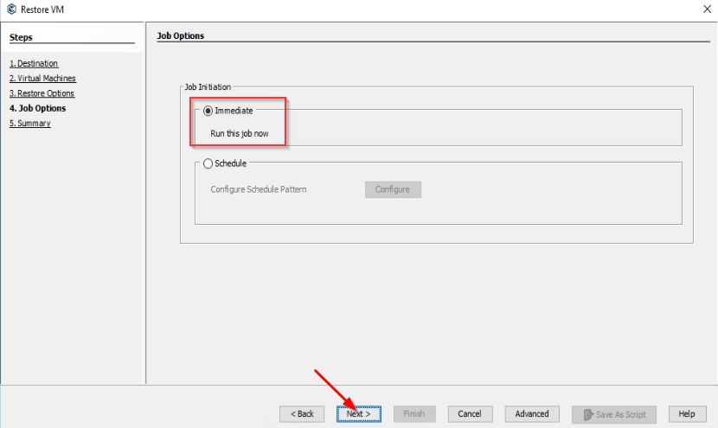

* + Summary dialog would look like below. Click ‘Finish’ to start restore job

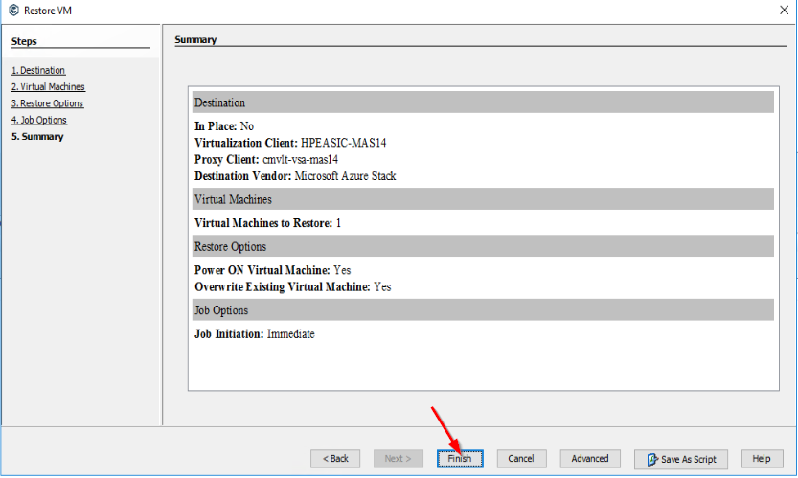

* + Job progress can be monitored in java app as below

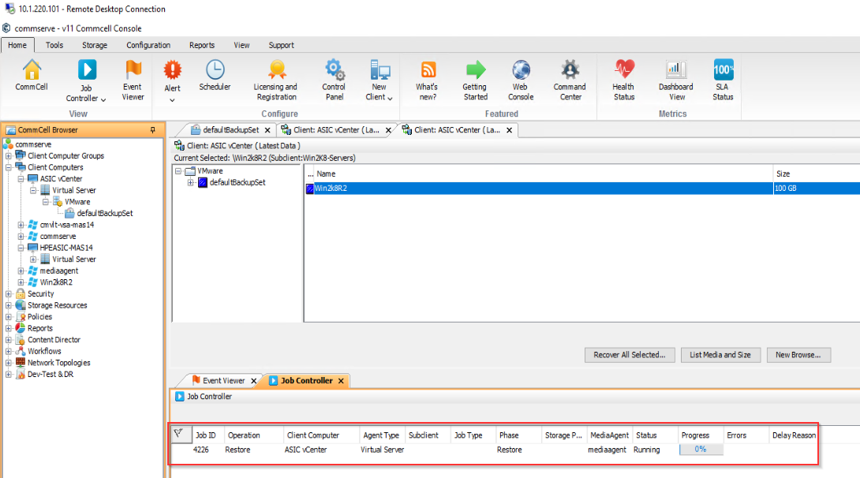

## Post Migration Verifications in Target Environment

* + 1. Verification 1: Virtual machine in Azure Stack Subscription

**<TBD>** - Need to capture procedure after verifying network connections to restored virtual machine

* + 1. Verification 2: Running SQL2008 server workload verification

**<TBD>** - Need to capture procedure with results from SMSS connected to SQL2008 database on restored virtual machine in Azure Stack subscription.

**<TBD> -** Need to draw conclusion with SQL query results with same query results run directly against database in source environment